[Table_Main]
研究报告Research Report
21 Oct 2025
Cirrus Aircraft (2507.HK)
Global Leader in Private Aviation: Dominating Personal Aviation with Safety, Innovation, and a Robust Ecosystem : Initiation
 |  | Cirrus Aircraft is a pioneer and global leader in the private aviation industry. Since its inception in 1984, Cirrus Aircraft has revolutionized personal aviation, delivering over 10,000 SR2X series aircraft and over 600 Vision Jets globally. The company holds a commanding lead in the private aviation sector, with 23.2% market share at the end of year 2024. For the financial performance, Cirrus demonstrated strong revenue expansion capability, surging from $587 million in 2020 to $1.197 billion in 2024; and net profit surged from $36 million in 2020 to $121 million in 2024, achieving a net profit CAGR as high as 32.3%. The net margin improved from 6.2% in 2020 to 10.1% in 2024.  Steady Growth in Private Jet Demand with Consumer-Oriented Scenarios. General aviation encompasses all aviation activities except military and scheduled commercial flights, including private and professional aviation. The global private aircraft market has seen steady growth in deliveries and value, with average selling prices also trending upward. The sustained growth in global private aircraft deliveries is driven by the expansion of high-net-worth individuals (HNWIs) and flight students, on the one hand, and by ongoing infrastructure development, on the other. The concentration of the industry is quite high, with Cirrus holding a leading position, especially in piston-engine aircraft. And it two major model lines showed upward tends in market share.  Cirrus is Differentiated by Industry-Leading Safety and a Holistic "Product + Service" Ecosystem. Cirrus’s product line, from SR2X series to the Vision Jet, caters to diverse needs, with the SR series targeting premium piston-engine segment, while the Vision Jet serving as a cost-effective option in the turbine-engined category. Its competitive edge stems from its pioneering safety features, including the life-saving "Whole-Airframe Parachute System (CAPS)" and the revolutionary "Safe Return Emergency Autoland". Crucially, Cirrus has evolved beyond manufacturing to offer a comprehensive "product + service" ecosystem, encompassing flight training, aircraft management, and financing. This high-retention model generates recurring revenue and strengthens brand loyalty, with high repurchase rate and strong pricing power.  Valuation & recommendation: We estimate Cirrus's revenue from 2025 to 2027 will reach USD1,426/ 1,646 / 1,928 million, with net profits of USD 162 / 199 / 242 million. Based on the DCF valuation model, we initiate coverage with an "Outperform" rating and a target price of USD 11.12 (HKD 86.72).  Risks: Fluctuation in raw material prices; Supply chain disruptions; Intensified market competition; Changes in customer demand; Policy changes.
  [Table_Info]
  评级调整Rating adjustment
  评级
  现价
  目标价
  市值
  发行股票数目
  1年股价最高最低值
  注：现价xx为yyyy年M月d日收盘价
  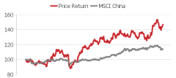
  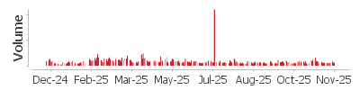
  资料来源： xxx
  [Table_Profit]
  营业收入
  (+/-)
  净利润
  (+/-)
  全面摊薄EPS
  毛利率
  净资产收益率
  市盈率
  资料来源：公司信息, xxx
[Table_Author]
Bin Yang
harryyang@hfisec.com.hk

Contents
1 Cirrus Aircraft: A Global Leader in Private Aviation with Over 40 Years of Experience 3
1.1 Company Overview 3
1.2 Ownership Structure &Management 3
1.3 Main Products 4
1.4 Financial Performance 5
2 Steady Growth in Private Jet Demand with Consumer-Oriented Scenarios 8
2.1 General Aviation Overview 8
2.2 Global Private Aircraft Market: Steady Growth in Deliveries with High Industry Concentration 11
3 High-Safety Products and Maturing Service Ecosystem Build Strong Brand Power 14
3.1 Product Matrix Covers Full-Spectrum Needs, High Safety Addresses Industry Pain Points 14
3.2 Comprehensive Manufacturing and Service Ecosystem Builds Irreplicable Competitive Strength 16
3.3 Repurchases and Pricing Power Demonstrate Strong Brand Strength 19
4. Future Outlook: Robust Yet Resilient Growth 20
5. Valuation& Recommendation 21
6. Risks 23

1 Cirrus Aircraft: A Global Leader in Private Aviation with Over 40 Years of Experience

1.1 Company Overview
Cirrus Aircraft Limited was founded in 1984 and is headquartered in Wisconsin, USA. It is a pioneer in the private aviation industry and a global market leader, dedicated to the design, development, manufacturing, and sales of industry-recognized premium aircraft.
In 1999, the company completed the first delivery of the SR20 aircraft, subsequently launching new models such as the SR22, SR2X, SR22TN, and SR22T. In 2011, following the financial crisis, CAIGA acquired Cirrus Aircraft for a price of $210 million. In 2016, the company achieved the first delivery of the Vision Jet. In 2017, Cirrus launched its Embark training program, and in 2018, it introduced Cirrus Services. In 2019, the company was incorporated as an exempted company in the Cayman Islands, laying a solid legal foundation for subsequent capital operations and international development. By the end of 2025H1, the company had delivered over 10,000 SR2X series aircraft and over 600 Vision Jets.

Figure: Cirrus Aircraft’s Milestone Events
Year | Milestone Events
1984 | Cirrus Design Corporation was founded.
1988 | Successful maiden flight of the VK-30.
1999 | First SR20 aircraft delivered to a customer.
2001 | First SR22 aircraft delivered to a customer.
2004-2006 | Launched SR2X Generation 2 models; First SR22TN delivered to a customer.
2007-2010 | Launched SR2X Generation 3 models; First SR22T delivered to a customer
2013 | Launched SR2X Generation 5 models.
2016 | First Vision Jet delivered to a customer.
2017 | Vision Jet received FAA Production Certificate; Launched SR2X Generation 6 models.
2019 | Incorporated as an exempted company in the Cayman Islands; Launched Vision Jet Generation 2.
2024 | Listed on the Hong Kong Stock Exchange (HKEX).

Source: Wind, HFI

1.2 Ownership Structure &Management
Cirrus Aircraft is ultimately controlled by the Aviation Industry Corporation of China (AVIC). AVIC holds a 73.39% stake in AVIC General Aviation, which in turn owns the direct controlling shareholder, AVIC General Aviation Hong Kong. Consequently, AVIC indirectly controls 58.71% of Cirrus Aircraft's issued shares.

Figure: Cirrus’s Ownership Structure
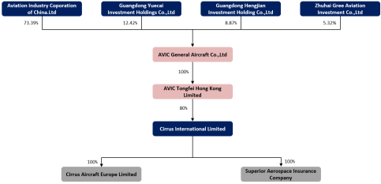
Source: Wind, HFI

The corporate governance team is stable and employs a localized management approach. Cirrus has retained its core technical personnel and workforce, maintaining a 100% localization rate for its US employees. The US team possesses significant decision-making autonomy. This localized model ensures a high level of business familiarity, which is conducive to the company's long-term operational development.

Figure: Senior Management Personnel of the Group
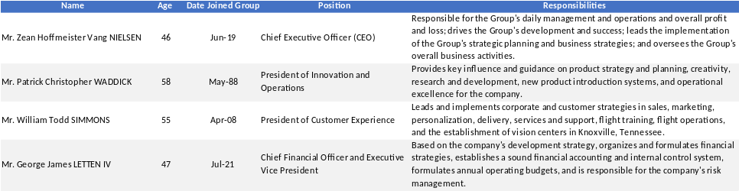
Source: Wind, HFI

1.3 Main Products
Cirrus's core products include the SR2X series single-engine piston aircraft and the Vision Jet.
- The SR2X series is one of Cirrus's core products, comprising three models: the SR20, SR22, and SR22T. This series is positioned as an entry-level single-engine piston aircraft, suitable for various uses such as private flying and flight training. Individual unit prices of these series vary from $600,000 to upwards of $1 million US dollars.
- The Vision Jet represents Cirrus's high-end product line. As the world's first single-engine jet aircraft to receive certification from the Federal Aviation Administration (FAA), it is marketed towards the premium private aviation segment.

Figure: Cirrus’s Main Products
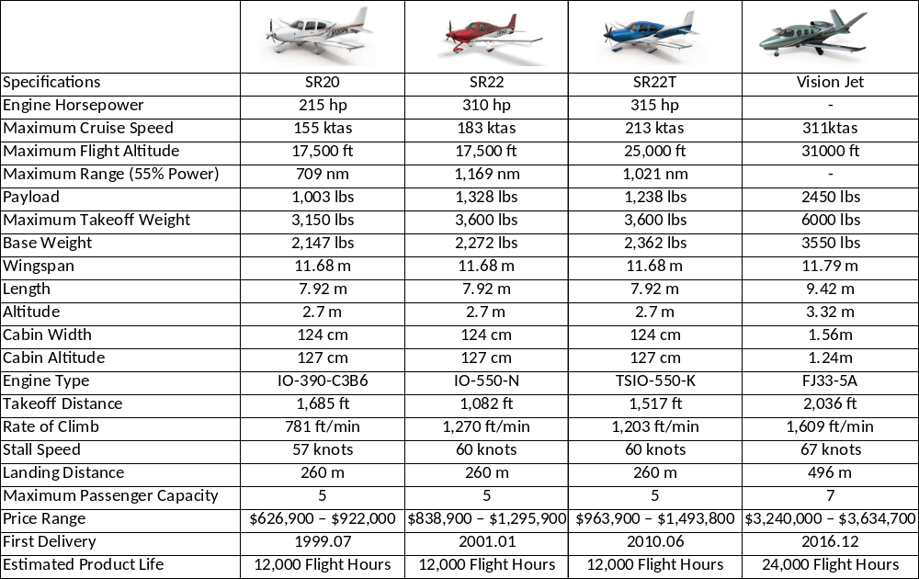
Source：Company Announcements, HFI

1.4 Financial Performance
Cirrus demonstrated strong revenue expansion capability between 2020 and 2024. Total revenue surged from $587 million in 2020 to $1.197 billion in 2024, achieving a Compound Annual Growth Rate (CAGR) of 19.4%. More specifically, in 2021, benefiting from the rebound in aviation demand post-pandemic, the growth rate reached 26.2%; in 2022-2023, affected by supply chain disruptions, the growth rate slowed down to around 20%; in 2024, through product structure optimization, the company achieved a year-on-year growth rate of 12.1%, which slowed compared to the previous year. The main reasons include: a natural pullback following the post-pandemic demand peak, high financing costs, and labor shortages.

Figure: Cirrus Aircraft Revenue and Growth Rate (in million USD)
Source: Wind, HFI

Regarding the business structure, aircraft manufacturing consistently maintained its dominant position, with its revenue contribution slightly increasing from 83.3% in 2020 to 85.5% in 2024. While the absolute value of the services business grew by 13.8%, its proportion decreased from 16.7% to 14.5%.

Figure: Cirrus Aircraft Segment Revenue and Growth Rates (mn USD)
Source: Wind, HFI

- For the aircraft part: from 2021 to 2024, Cirrus's total aircraft revenue increased from USD 619.61 million to USD 915.65 million. At the end of 2024, deliveries of the SR2X series and Vision Jet increased to 630 units and 101 units respectively, while their average selling prices rose by 9.7% and 8.0% respectively.

Figure: Cirrus Aircraft Segment Revenue (mn USD) |  | Figure: Cirrus Aircraft Volume Breakdown (mn units)
Source: Wind, HFI |  | Source: Wind, HFI

- For the service part: from 2021 to 2023, Cirrus's total service revenue increased from USD 118.5 million to USD 152.1 million, with the proportion of aftermarket parts/maintenance rising from 40.5% to 53.1%, and the proportion of pre-owned aircraft sales increasing from 8.7% to 17.5%.

Figure: 2021-2023 Cirrus After-Sales Service Revenue Breakdown
Source: Wind, HFI

The company's profitability has continued to improve from 2020 to 2024.
1) From the perspective of gross profit and gross margin: From 2020 to 2024, the company's gross profit increased from $185 million to $414 million, with a compound annual growth rate (CAGR) of 22.3% for gross profit. The gross margin rose from 31.6% in 2020 to 34.6% in 2024.
2) From the perspective of net profit and net margin: Net profit surged from $36 million in 2020 to $121 million in 2024, achieving a net profit CAGR as high as 32.3%. The net margin improved from 6.2% in 2020 to 10.1% in 2024.
The substantial enhancement in profitability was primarily driven by the product pricing strategy (with the average price of the SR2X series increasing by 9.8% annually), the rising proportion of high-gross-margin business (with the Vision Jet contributing 29.9% of revenue), and production efficiency improvements brought about by the Cirrus Operating System (COS).
3) Expense Ratios Remained Stable: Cirrus Aircraft's selling expense ratio remains at around 12%, administrative expense ratio stays at 10%, and financial expense ratio is maintained at 0.4%.

Figure: Cirrus Aircraft Net Profit/Gross Profit and Growth Rates (in million USD) |  | Figure: Cirrus Aircraft Net Profit Margin / Gross Profit Margin
Source: Wind, HFI |  | Source: Wind, HFI

Figure: Cirrus Aircraft Expense Ratio
Source: Wind, HFI

2 Steady Growth in Private Jet Demand with Consumer-Oriented Scenarios

2.1 General Aviation Overview
General aviation encompasses all aviation activities except military and scheduled commercial flights, including private and professional aviation.
Private aviation refers to non-commercial operations of fixed-wing general aviation aircraft, such as personal flying and flight training, targeting individual owners, instructors, and enthusiasts. These aircrafts typically cost under $7 million and accounted for 76% of general aviation deliveries.
Professional aviation includes aircraft used for corporate/charter services and specialized applications. These aircrafts often have the capability of long-range, transcontinental, and intercontinental flights with advanced technology and multiple engines for high-speed travel.

Figure: Private Aviation Aircraft Vs. Profession Aviation Aircraft
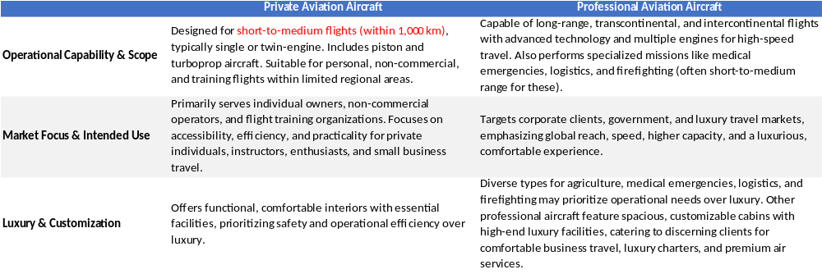
Source：Company Announcements, HFI

Current mainstream aircraft types include piston-engine and turbine-engine models.
- Piston-engine aircraft use traditional reciprocating engines, where fuel-air mixture combustion drives pistons to power the propeller, generating thrust. They are economical and suited for low-speed, short-range flights, and merged as the top choice for short-distance transportation, flight training, and personal use.

Figure: Types and History of piston-engine aircraft
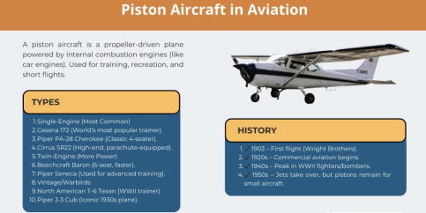
Source: Tsunami Air, HFI

- Turbine-engine aircraft are classified into four main types, in which turboprop and turbojet aircraft dominate the mainstream. From cost and performance perspectives, turboprop and turbojet aircraft demonstrate superior adaptability and reliability in medium- to long-range flights, high-altitude operations, and complex weather conditions, making them widely used in business travel, emergency rescue, and specialized industrial tasks.
- Turbojet: Produces thrust via high-speed exhaust gases; ideal for high-altitude, high-speed flight. However, high fuel consumption has led to limited use in modern civil aviation.
- Turbofan: Adds a fan to bypass some air around the core, improving propulsion efficiency, fuel economy, and reducing noise. It is the primary choice for commercial airliners and military transports.
- Turboprop: Drives a propeller via turbine, converting jet power to mechanical energy; offers high fuel efficiency and is widely used in regional airliners and military transports, though limited in high-speed performance.
- Turboshaft: Fully converts jet power to shaft power; used in helicopters and other rotorcraft, enabling vertical takeoff, landing, and hovering.

Figure: Comparison of Turbine-engine Aircraft
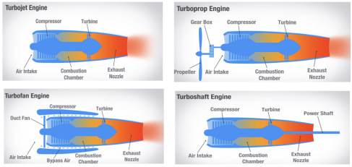
Source: Boldmethod, HFI
Global general aviation aircraft deliveries have shown steady growth. From 2019 to 2023, deliveries increased from 2,657 units to 3,050 units, representing a 5-year CAGR of 3.5%. The corresponding delivery value remained relatively stable, at $23.6 billion in 2019 and $23.4 billion in 2023. According to forecasts from the General Aviation Manufacturers Association (GAMA), the 4-year CAGR for both deliveries and delivery value from 2024 to 2028 is expected to exceed 6%, with deliveries projected to reach 3,779 units and delivery value to reach $34.24 billion by 2028.

Figure: Worldwide General Aviation Aircraft Deliveries (units) |  | Figure: Worldwide General Aviation Aircraft Deliveries (USD value)
Source: GAMA, Wind, HFI |  | Source: GAMA, Wind, HFI

The global general aviation market exhibits growth centered on North America, with Europe remaining stable, Asia-Pacific facing adjustment pressures, and Latin America/Middle East & Africa at lower levels. In the future, as national policies take effect—particularly China's continued push in low-altitude economy and general aviation—the Asia-Pacific region's market share is expected to rebound. Meanwhile, advancements in multimodal transportation and airspace management reforms will inject new momentum into the long-term development of the global general aviation industry.
Figure: Global General Aviation Aircraft Deliveries by Region (in units)
Source: GAMA, Wind, HFI

2.2 Global Private Aircraft Market: Steady Growth in Deliveries with High Industry Concentration
The global private aircraft market has seen steady growth in deliveries and value, with average selling prices also trending upward. Private aircraft are increasingly favored for their high flexibility, privacy, safety, time efficiency, and year-round usability. Global deliveries rose from 1,894 units in 2019 to 2,215 in 2023 (4-year CAGR: 4%), while delivery value increased from $2.7 billion to $3.7 billion (4-year CAGR: 8.5%). Average selling prices climbed from $1.43 million in 2019 to $1.67 million in 2023, driven mainly by rising raw material and labor costs, as well as increased R&D investment in premium models by manufacturers.

Figure: Worldwide Private Aircraft Deliveries (units) |  | Figure: Worldwide Private Aircraft Deliveries (USD value)
Source: GAMA, Wind, HFI |  | Source: GAMA, Wind, HFI

Figure: Historical Trend of Average Selling Price for Private Aircraft (in million USD)
Source: GAMA, Wind, HFI

The sustained growth in global private aircraft deliveries is driven by the expansion of high-net-worth individuals (HNWIs) and flight students, on the one hand, and by ongoing infrastructure development, on the other.
1) Private aircraft are a popular choice for HNWIs in short-haul commuting, sightseeing, and recreational activities. From 2018 to 2023, the global HNWI population grew from 52 million to 74 million (CAGR: 7.2%), and is projected to reach 120 million people by 2028, with a compound annual growth rate (CAGR) of 10.6% from 2024 to 2028.
2) The number of flight students in the United States increased from 197,700 in 2019 to 316,500 in 2023, with a Compound Annual Growth Rate (CAGR) of 12.5%.
3) Infrastructure expansion has laid a solid foundation: according to Statista, the U.S. had 14,776 private-use airports in 2022, an increase of 13863 since 2014.

Figure: Number of private airports in the United States from 1990 to 2022
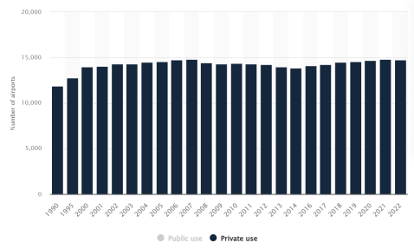
Source: Statista, HFI

The industry exhibits high concentration, with Cirrus holding a leading position. In the global private aircraft market, Cirrus, Cessna (owned by Textron Aviation since 2014), and Diamond Aircraft are the primary manufacturers. According to GAMA reports, in 2023, deliveries by Cirrus, Cessna, and Diamond were 708, 618, and 273 units respectively. The three companies combined accounted for 47.6% of total sales market share, with Cirrus holding 23.2%.
Figure: Aircraft Manufacturer Ranking
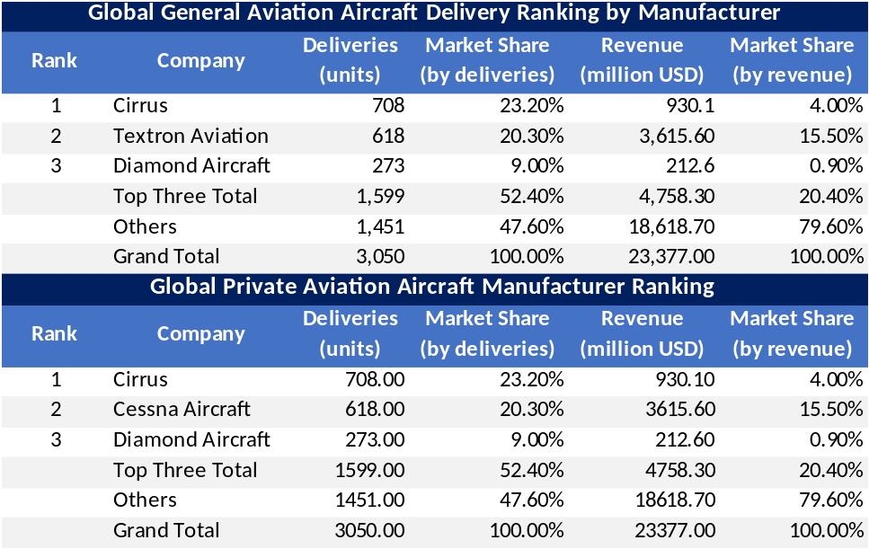
Source: GAMA, Wind, HFI

Cirrus holds a prominent leading position in piston-engine aircraft, and its two major model lines showed upward trends in market share.
1）Piston-engine aircraft: From a shipment perspective, in 2024, the top five global piston-engine aircraft manufacturers accounted for a combined share of 84.6%, with Cirrus leading at 31.9% (up from approximately 24.1% in 2020). Cirrus is positioned in the premium segment and leads in shipment volume.
Figure: Market Share of Global Piston Aircraft Deliveries (in units)
Source: GAMA, Wind, HFI

2）Jet aircraft: In 2024, the top five global jet aircraft manufacturers accounted for a combined share of 86.91%, with Cirrus ranking fifth at approximately 13.22% (up from about 10.0% in 2019).

Figure: Market Share of Global Jet Aircraft Deliveries (in units)
Source: GAMA, Wind, HFI

3 High-Safety Products and Maturing Service Ecosystem Build Strong Brand Power

3.1 Product Matrix Covers Full-Spectrum Needs, High Safety Addresses Industry Pain Points
The "entry-level → advanced → flagship" product matrix covers the full spectrum of needs from novice to high-net-worth clients, enabling precise market segmentation and revenue diversification. At the core of Cirrus Aircraft's product strategy is the SR2X series (SR20, SR22, and SR22T), forming a graduated lineup from entry-level to high-performance single-engine piston aircraft: the SR20 targets the basic segment, while the SR22/SR22T address more advanced demands through ongoing performance upgrades, with the entire series standardly accommodating 4 adults + 1 child.
Complementing this is the premium-positioned Vision Jet, offering superior flight performance, advanced technology, and a larger cabin (5 adults + 2 children) at a higher price point.

Figure: Main Products
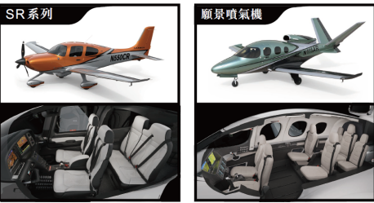
Source: Wind, HFI

Compared to industry peers, Cirrus's two main product lines have distinct strategic positioning: the SR series targets the premium piston-engine segment, while the Vision Jet serves as a cost-effective option in the turbine-engined category.
1）Piston-engine Aircraft: In terms of average price comparison, Cirrus's three main models—SR20, SR22, and SR22T—have base prices of $630,000, $840,000, and $960,000 respectively, higher than the industry average delivery price of $760,000 for piston-engine aircraft.
2）Turbine-engined Aircraft: Cirrus is positioned for high cost-performance, with its single Vision Jet model (7-seater) having a base price of $3.24 million. For comparison: Piper M600 (6-seater) at $3.52 million, Epic E1000 (6-seater) at $4.19 million, Daher TBM960 (6-seater) at $4.78 million, Pilatus PC-12 NGX (11-seater) at $5.72 million, and Textron Citation M2 (7-seater) at $5.86 million.

Figure: Comparison of Cirrus Products with Competitors in Terms of Price, Performance, and Specifications
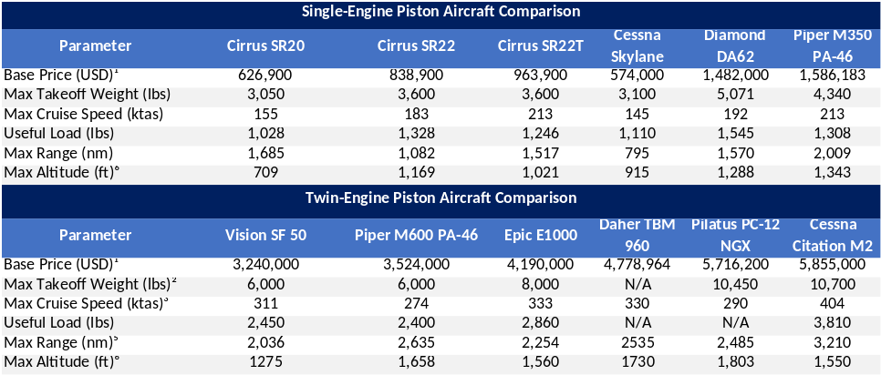
Source: Wind, HFI

Leading product safety addresses the industry's biggest pain point. According to Frost & Sullivan, Cirrus achieves a total accident rate three times lower than the general aviation industry average per 100,000 flight hours. Cirrus resolves consumer safety concerns through two key differentiating features.
- Whole-Airframe Parachute System: Patented and standard on every Cirrus aircraft, it has saved over 250 lives since its introduction in 1999.
- Safe Return Emergency Autoland: First introduced on the Vision Jet in late 2019 and on the SR Series G7+ in May 2025, this system enables passengers to safely land the aircraft with a single button press if the pilot becomes incapacitated.

Figure: Whole-Airframe Parachute System |  | Figure: Safe Return Emergency Autoland
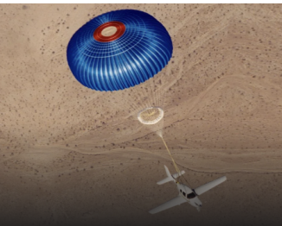 |  | 
Source: Company Official Website, HFI |  | Source: Company Official Website, HFI

Figure: Mitigation Measures Under Different Situations
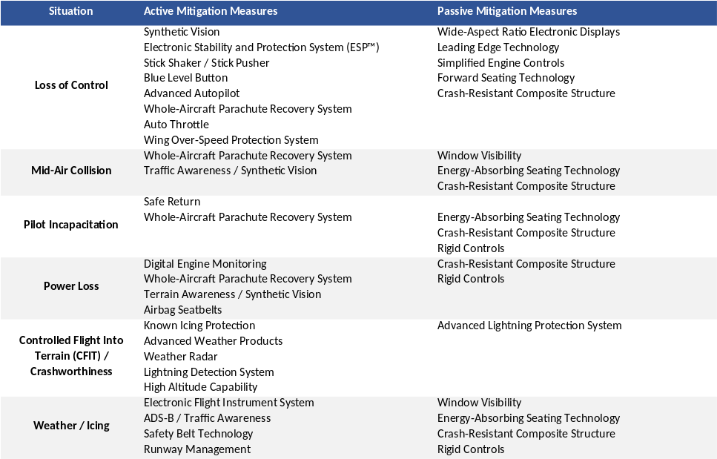
Source: Wind, HFI

3.2 Comprehensive Manufacturing and Service Ecosystem Builds Irreplicable Competitive Strength
Cirrus Aircraft ensures efficient production synergy and supply chain stability through its two core manufacturing bases and long-term partnerships with leading global suppliers.

- Two core manufacturing bases: The Grand Forks factory in North Dakota focuses on the research, development, and production of advanced composite material components such as carbon fiber, while the Duluth factory in Minnesota is responsible for aircraft final assembly and testing, achieving efficient collaboration through vertical integration of metal component manufacturing and subsystem production.
Figure: Cirrus Major Properties Overview
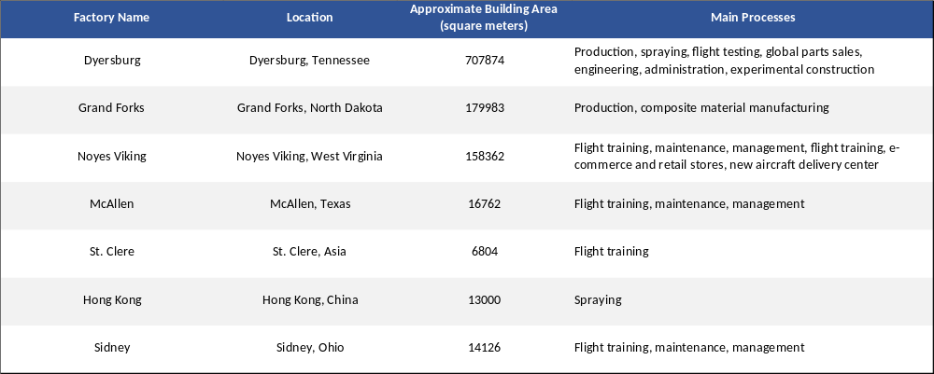
Source：Wind, HFI
- Cirrus has a comprehensive supply chain management system, primarily ensuring the quality of raw materials and the stability of component supplies by establishing long-term cooperative relationships with globally leading suppliers. The company's suppliers mainly come from manufacturers and developers of avionics systems, composite materials, propulsion systems, as well as cabin and interior systems.
Figure: Cirrus Major Suppliers
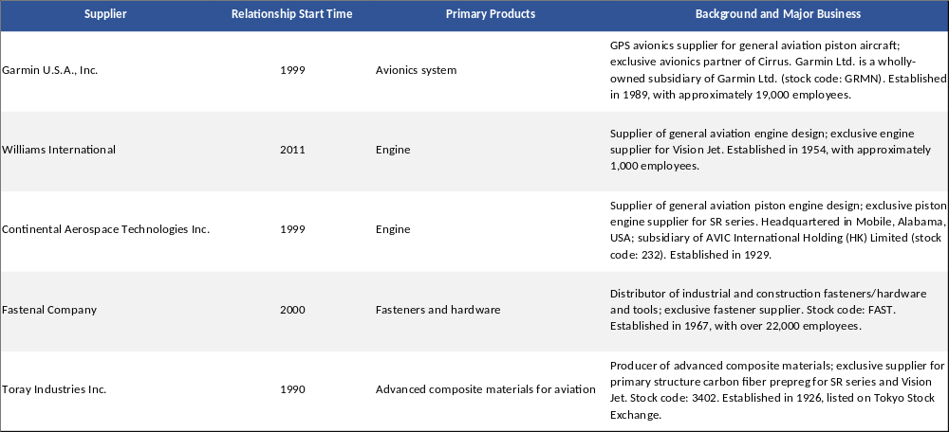
Source：Wind, HFI
Cirrus continuously builds its service ecosystem to enhance customer loyalty, offering full-lifecycle services including pilot training centers, flight training, maintenance, aircraft management, and financing/insurance. Using aircraft sales as an entry point, it extends monetization across the ownership cycle, creating a high-stickiness customer relationship loop and marking a strategic shift from pure hardware sales to a "product + service" ecosystem.

1) Aircraft Maintenance & Support Network
Cirrus operates 4 company-owned service centers and a global network of 242 authorized service centers (distribution: 183 in North America, 29 in Europe, 7 in Asia, etc.), providing 24/7 worldwide AOG (Aircraft on Ground) mobile support. Key maintenance programs include: JetStream Program: Comprehensive prepaid maintenance plan (covering parts replacement, training, 10-year airframe overhaul, etc.), priced approximately USD 96,000–225,000 per year, with 100% enrollment rate among eligible owners; Cirrus ASSIST: Rapid AOG response + interior/exterior upgrades and modifications, charged based on labor hours and parts; Cirrus Direct: Online platform allowing customers to directly order parts and upgrades, billed per component.

Figure: Aircraft Maintenance & Support Network

Source: Company Official Website, HFI

2）Pre-Owned Aircraft Business
Cirrus operates the world's largest and most active pre-owned Cirrus aircraft trading platform. The company acquires used aircraft as inventory and resells them at a markup to earn the price difference (without charging any additional specific service fees).

- Flight Training Services
As of December 31, 2023, the company operates four factory training centers in Tennessee, Arizona, Texas, and Florida in the United States, and has 118 authorized training centers across 13 countries (of which 94 are in the United States and 16 in Europe). Key programs include: On-site simulator & transition training; Cirrus Approach — Online courses for SR2X series & Vision Jet; Cirrus Embark — Free transition training for pre-owned SR2X / Vision Jet buyers; Private pilot license training (including enhanced SR22 courses)

Figure: Cirrus Training Center |  | Figure: Cirrus Authorized Training Center
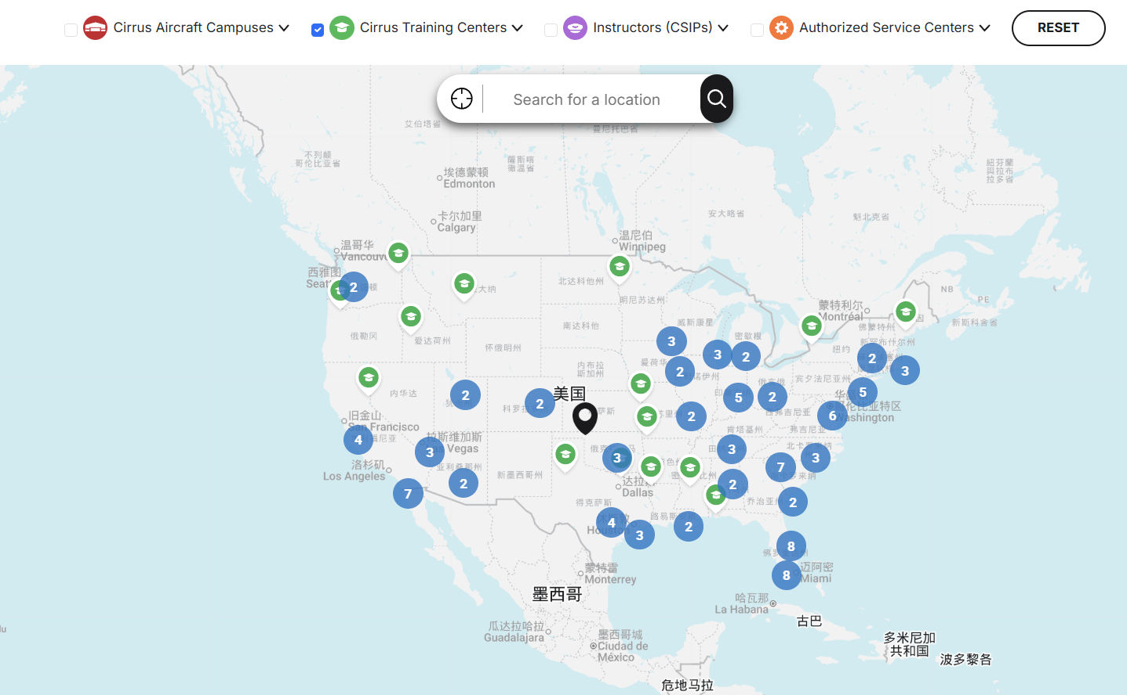 |  | 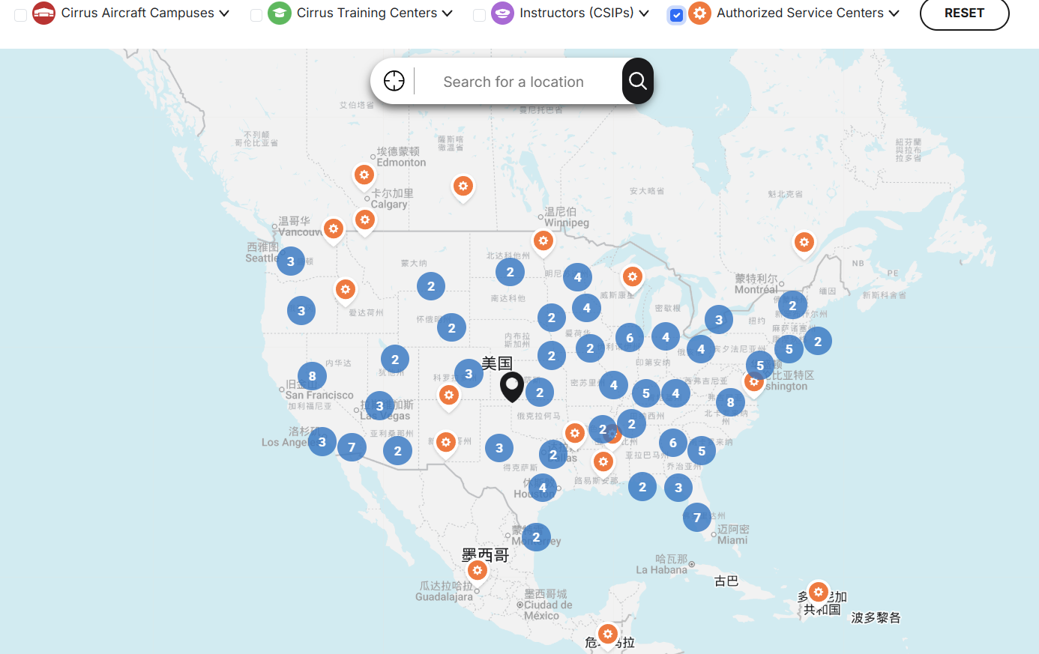
Source: Company Official Website, HFI |  | Source: Company Official Website, HFI

Figure: Cirrus Aircraft Campuses |  | Figure: Instructors(CSIPs)
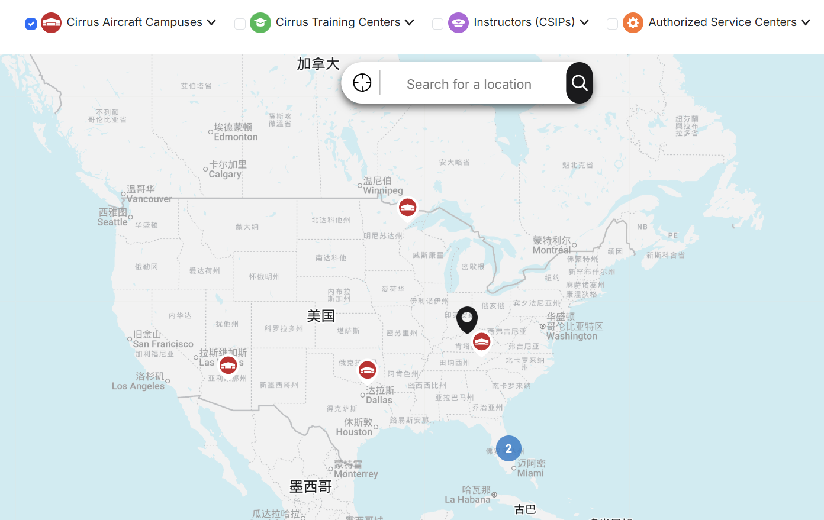 |  | 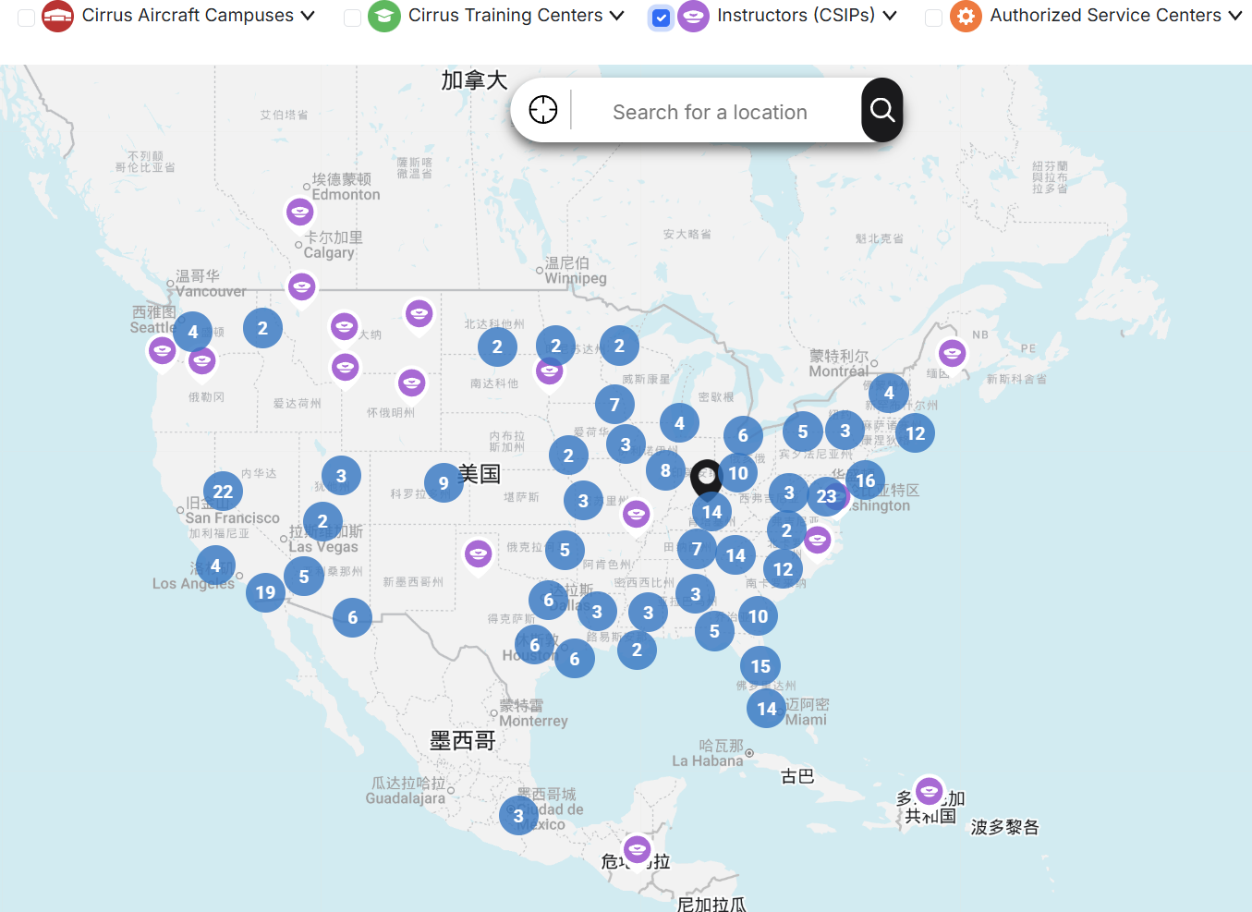
Source: Company Official Website, HFI |  | Source: Company Official Website, HFI

4) Aircraft Management & Value-Added Services
Cirrus offers Vision Air, a premium full-year management service for Vision Jet owners priced at USD 300,000–485,000 annually, and Cirrus One, a similar program for SR series aircraft starting from USD 1,500 per month (varies by service). Through third-party partners, Cirrus Finance & Insurance provides financing and insurance solutions, generating brokerage commissions of USD 1.6 million in 2021 and 2022, rising to USD 2.7 million in 2023, while cumulatively facilitating over 3,100 financing deals and insurance coverage for more than 900 aircraft.

Figure: Cirrus IQ App
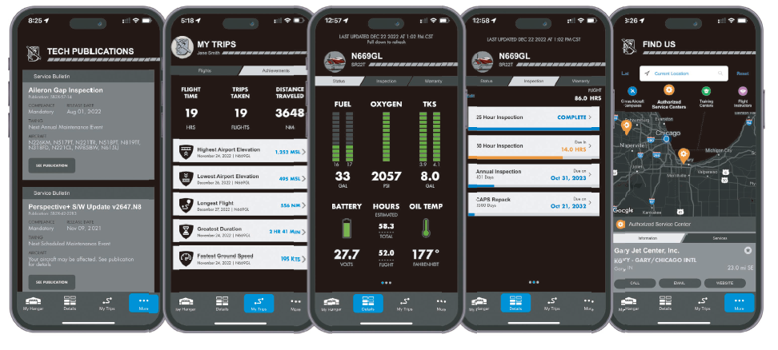
Source: Company Announcement, HFI

3.3 Repurchases and Pricing Power Demonstrate Strong Brand Strength
Cirrus enjoys a high repurchase rate and strong pricing power, demonstrating its robust brand strength. Cirrus Aircraft's average price CAGR over the past 9 years reached 7.5%, outperforming U.S. per capita disposable income growth of 5.24%, and U.S. CPI growth of 1.38%, and luxury brand Ferrari's 4.8% over the same period, highlighting Cirrus's robust pricing power. From a repeat-purchase perspective, according to the company's prospectus, 75% of Vision Jet sales come from existing customers, further underscoring its powerful brand strength.

Figure: Average Price of Cirrus from 2015 to 2024 |  | Figure: Average Price of Ferrari from 2015 to 2024
Source: GAMA, HFI |  | Source: Company Official Website, HFI

Figure: U.S. Per Capita Disposable Income from 2015 to 2024 |  | Figure: U.S. CPI from 2015 to 2024
Source: Wind, HFI |  | Source: Wind, HFI

4. Future Outlook: Robust Yet Resilient Growth
Strong Order Backlog Ensures Solid Performance Visibility. Due to differences in customer ground and configuration preferences, the delivery cycle for each aircraft paid for by customers under order typically ranges from 18 to 24 months. According to GAMA data, Cirrus delivered 555 aircraft in the first three quarters of 2025, with a still ample order backlog that provides strong support for future performance.

Figure: Cirrus Aircraft Quarterly Shipments (Units) |  | Figure: Cirrus Order and Delivery Statistics
 |  | 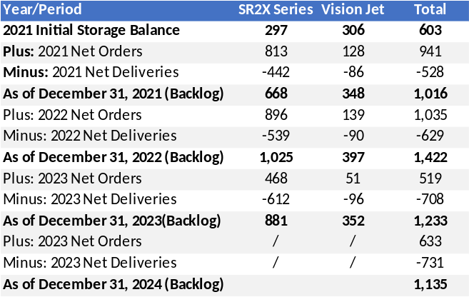
Source: GAMA, HFI |  | Source: Company Annual Report, Company prospectus, HFI

Planned capacity expansion support steady growth. Historically, Cirrus has scaled annual deliveries from over 500 to over 700 units and is now operating near full capacity. In June 2025, the company announced a $13 million investment to expand its Grand Forks, North Dakota facility, with operations expected to commence in 2026, driving gradual increases in delivery volume.

Figure: Production Capacity & Utilization Rate
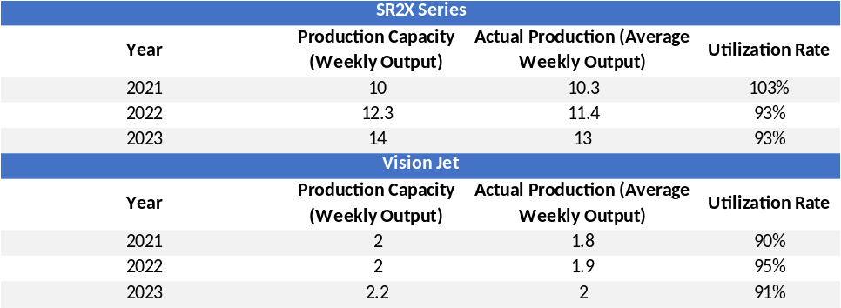
Source: Company Announcement, HFI

Broad growth potential in global general aviation services market. The global GA aircraft services market has shown strong growth momentum in recent years, offering Cirrus substantial room for expansion. As the fleet of general aviation aircraft continues to grow—particularly with increased usage by individuals and SMEs—services such as FBO operations, MRO, parts supply, upgrades, pilot training, insurance, and financing are becoming increasingly vital. For leading manufacturers with large, mature fleets, these services typically contribute 35-40% of total revenue. In contrast, Cirrus's aftermarket services accounted for only 14.5% of revenue in 2024. As its in-service fleet expands, significant upside remains in service revenue contribution.

Figure: Cirrus After-Sales Service Revenue Proportion |  | Figure: Reasons for the Growth in Global General Aviation Aircraft Service Demand
 |  | 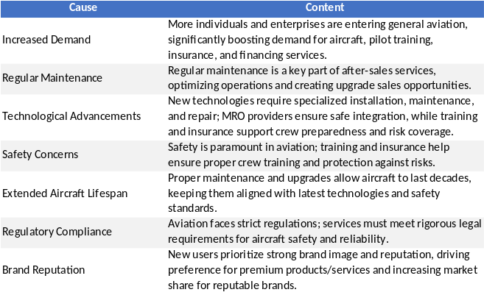
Source: Wind, HFI |  | Source: Wind, HFI

5. Valuation& Recommendation

5.1 Profit Forecast
- Total Revenue
1) SR Series Aircraft: SR2X total revenue is projected to be $823 million/$971 million/$1.143 billion in 2025-2027, representing year-on-year growth of 18.8%/17.97%/17.72%.
Deliveries are projected to be 693/750/810 aircraft, representing an average annual growth of approximately 8%; the average selling price is projected to be $1.19/$1.29/$1.41 million, representing an average annual increase of 8%–9%.
2) Vision Jet Series Aircraft: Total revenue is projected to be $404 million/$444 million/$514 million in 2025-2027. Deliveries are projected to be 110/114/120 aircraft, representing an average annual growth of approximately 6%; the average selling price is projected to be $3.67/$3.97/$4.28 million, representing an average annual increase of 8%.
3) Service Business: With the aging of existing models and the increasing demand for parts replacement, the after-sales service business will continue to perform strongly, with projected revenues of US$199 million, US$231 million, and US$270 million for 2025, 2026, and 2027, respectively, representing year-on-year growth of 15%, 16%, and 17%.
Based on the above, the company's total revenue is projected to be US$1.426 billion, US$1.654 billion, and US$1.928 billion for 2025, 2026, and 2027, respectively.

Figure: Revenue Volume and Price Breakdown Assumptions (mn USD)
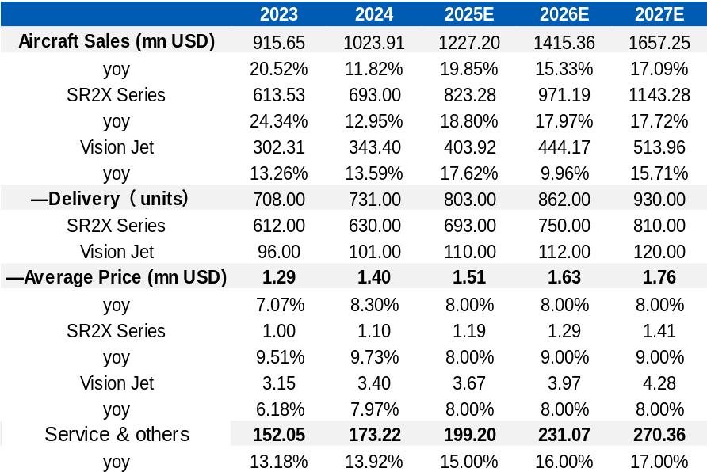
Source: Wind, HFI

- Gross Profit Margin
Driven by product structure upgrades and high-margin services, the company's overall gross profit margin is expected to steadily improve. Specifically, the gross profit margin for the aircraft business is projected to reach 34.9%/35.1%/35.5% in 2025-2027, while the gross profit margin for the service business is projected to be 34.5%/36.2%/38.9%. In summary, the company's overall gross profit margin is expected to be 34.8%/35.3%/36.0%.
- Period Expense Ratio
1）Sales Expense Ratio: In 2023 and 2024, the sales expense ratio was 10.00% and 10.32%, respectively. As the company's economies of scale become more apparent and its cost control capabilities improve, the sales expense ratio is projected to be 10.00%/9.90%/9.80% in 2025-2027.
2）Administrative Expense Ratio: The company's administrative expense ratio has decreased year by year, from 12.66% in 2023 to 11.80% in 2024. The projected administrative expense ratios for 2025-2027 are 10.90%/10.60%/10.40%, respectively.

In summary, the company's net profit is projected to be US$162 /US$199 /US$242 million for 2025-2027, representing year-on-year growth rates of 34.2%/23.1%/21.3%, respectively.

5.2 Valuation Analysis
Based on the discounted cash flow (DCF) valuation model, we have calculated the company's future operating cash flow and, taking into account the industry's growth prospects, the company's competitive position, and the trend of improving profitability, we assign a target price of US$11.12 (HK$86.72). We are initiating coverage of Cirrus Aircraft with an "Outperform" rating.

Figure: DCF Model
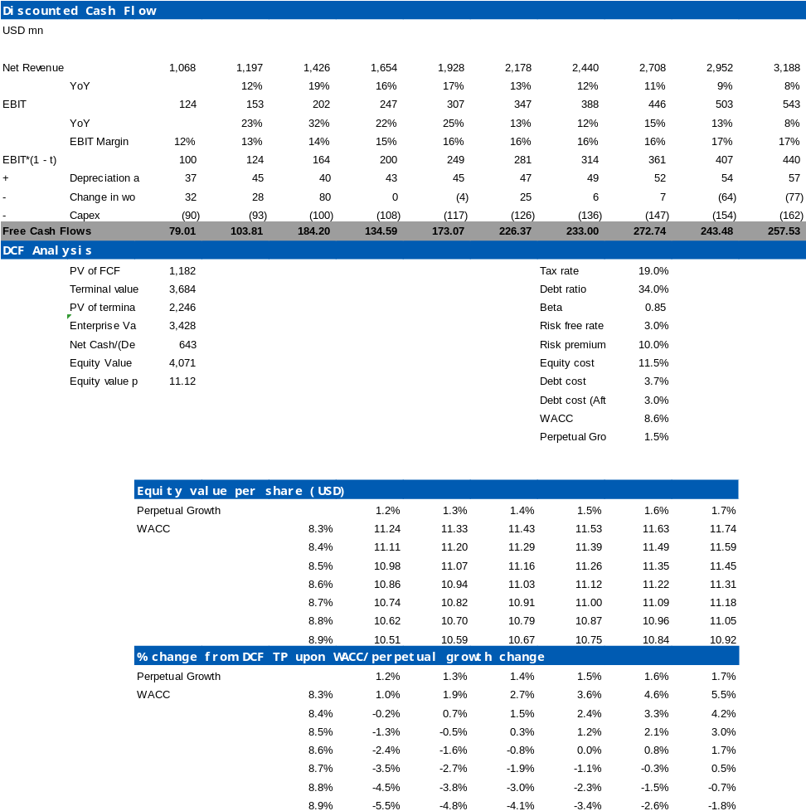
Source: Wind, HFI

Table: Financial Summary
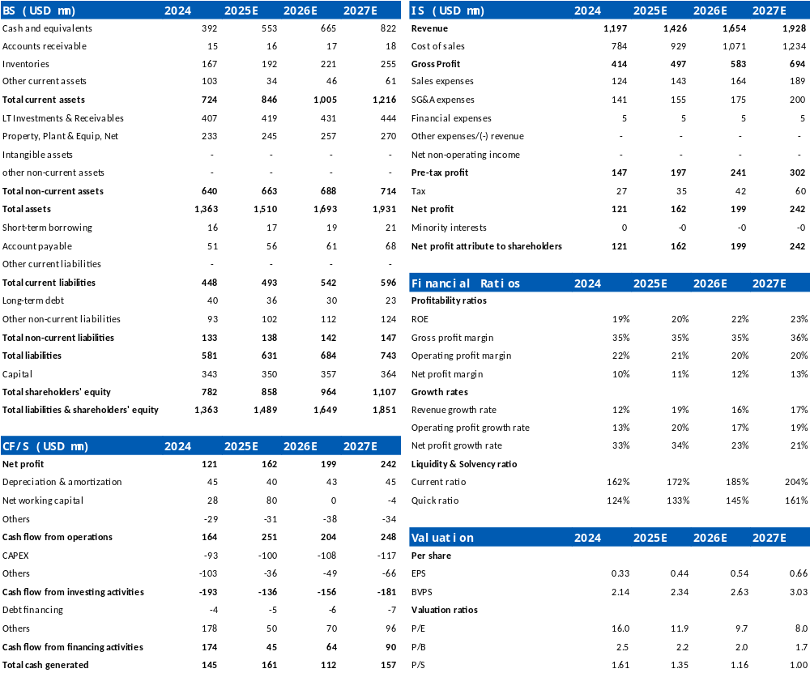
Source: Company Announcements, HFI

6. Risks
Fluctuation in raw material prices; Supply chain disruptions; Intensified market competition; Changes in customer demand and preferences; Policy implementation falling short of expectation.

[Table_disclaimer]
附录APPENDIX
重要信息披露
本研究报告由华福国际（香港）金融控股有限公司（下称华福国际）分销，在其许可的司法管辖区内从事证券活动。
IMPORTANT DISCLOSURES
This research report is distributed by HuaFu International (HK) Financial Holdings Limited (referred as HuaFu International below), which is authorized to engage in securities activities in its respective jurisdiction.
分析师认证Analyst Certification:
我， xxxx，在此保证（i）本研究报告中的意见准确反映了我们对本研究中提及的任何或所有目标公司或上市公司的个人观点，并且（ii）我的报酬中没有任何部分与本研究报告中表达的具体建议或观点直接或间接相关；及就此报告中所讨论目标公司的证券，我们（包括我们的家属）在其中均不持有任何财务利益。I, xxxx, certify that (i) the views expressed in this research report accurately reflect my personal views about any or all of the subject companies or issuers referred to in this research and (ii) no part of my compensation was, is or will be directly or indirectly related to the specific recommendations or views expressed in this research report; and that I (including members of my household) have no financial interest in the security or securities of the subject companies discussed.
利益冲突披露Conflict of Interest Disclosures
华福国际及其某些关联公司可从事投资银行业务和/或对本研究中的特定股票或公司进行做市或持有自营头寸。就本研究报告而言，如需了解其中提到的某一公司信息，请发邮件至lcd@hfisec.com.hk）
HuaFu International and some of its affiliates may engage in investment banking and / or serve as a market maker or hold proprietary trading positions of certain stocks or companies in this research report. As far as this research report is concerned, please send an email to lcd@hfisec.com.hk if the information about any company mentioned in this report is needed).
评级定义（从2020年7月1日开始执行）：
华福国际采用相对评级系统来为投资者推荐我们覆盖的公司：优于大市、中性或弱于大市。投资者应仔细阅读华福国际的评级定义。并且华福国际发布分析师观点的完整信息，投资者应仔细阅读全文而非仅看评级。在任何情况下，分析师的评级和研究都不能作为投资建议。投资者的买卖股票的决策应基于各自情况（比如投资者的现有持仓）以及其他因素。
分析师股票评级
优于大市，未来12-18个月内预期相对基准指数涨幅在10%以上，基准定义如下
中性，未来12-18个月内预期相对基准指数变化不大，基准定义如下
弱于大市，未来12-18个月内预期相对基准指数跌幅在10%以上，基准定义如下
各地股票基准指数：日本 – TOPIX, 韩国 – KOSPI, 台湾 – TAIEX, 印度 – Nifty100, 美国 – SP500; 其他所有中国概念股 – MSCI China.
Ratings Definitions (from 1 Jul 2020):
HuaFu International uses a relative rating system using Outperform, Neutral, or Underperform for recommending the stocks we cover to investors. Investors should carefully read the definitions of all ratings used in HuaFu International Research. In addition, since HuaFu International Research contains more complete information concerning the analyst's views, investors should carefully read HuaFu International Research, in its entirety, and not infer the contents from the rating alone. In any case, ratings (or research) should not be used or relied upon as investment advice. An investor's decision to buy or sell a stock should depend on individual circumstances (such as the investor's existing holdings) and other considerations.
Analyst Stock Ratings
Outperform: The stock’s total return over the next 12-18 months is expected to exceed the return of its relevant broad market benchmark by over 10%, as indicated below.
Neutral: The stock’s total return over the next 12-18 months is expected to be in line with the return of its relevant broad market benchmark, as indicated below. Underperform: The stock’s total return over the next 12-18 months is expected to be below the return of its relevant broad market benchmark by over 10%, as indicated below.
Benchmarks for each stock’s listed region are as follows: Japan – TOPIX, Korea – KOSPI, Taiwan – TAIEX, India – Nifty100, US – SP500; for all other China-concept stocks – MSCI China.

华福国际非评级研究：华福国际发布计量、筛选或短篇报告，并在报告中根据估值和其他指标对股票进行排名，或者基于可能的估值倍数提出建议价格。这种排名或建议价格并非为了进行股票评级、提出目标价格或进行基本面估值，而仅供参考使用。
HuaFu International Non-Rated Research: HuaFu International publishes quantitative, screening or short reports which may rank stocks according to valuation and other metrics or may suggest prices based on possible valuation multiples. Such rankings or suggested prices do not purport to be stock ratings or target prices or fundamental values and are for information only.
华福国际A股覆盖：华福国际可能会就中国A股进行覆盖及评级。华福证券，华福国际于福州的母公司，也会于中国发布中国A股的研究报告。但是，华福国际使用与华福证券不同的评级系统，且可能有完全独立的不同研究覆盖团队，所以华福国际与华福证券的中国A股评级、目标价乃至分析逻辑可能有所不同。
HuaFu International Coverage of A-Shares: HuaFu International may cover and rate A-Shares . HuaFu Securities, the ultimate parent company of HuaFu International based in FuZhou, covers and publishes research on these same A-Shares for distribution in mainland China. However, the rating system employed by HuaFu International differs from that used by HuaFu Securites and even the teams covering the same A-share stocks might be totally independently different, as a result there may be a difference in their coverage ratings, target prices and research logics for the same A-share stocks.
重要免责声明：
本报告由华福国际发行，该公司是根据香港证券及期货条例（第571章）持有第4类受规管活动（就证券提供意见）的持牌法团。
本文件所载信息和观点已被编译或源自可靠来源，但华福国际或任何其他属于华福国际的成员对其准确性、完整性和正确性不做任何明示或暗示的声明或保证。本文件中所有观点均截至本报告日期，如有更改，恕不另行通知。本文件仅供参考使用。文件中提及的任何公司或其股票的说明并非意图展示完整的内容，本文件并非/不应被解释为对证券买卖的明示或暗示地出价或征价。在某些司法管辖区，本文件中提及的证券可能无法进行买卖。如果投资产品以投资者本国货币以外的币种进行计价，则汇率变化可能会对投资产生不利影响。过去的表现并不一定代表将来的结果。某些特定交易，包括设计金融衍生工具的，有产生重大风险的可能性，因此并不适合所有的投资者。您还应认识到本文件中的建议并非为您量身定制。分析师并未考虑到您自身的财务情况，如您的财务状况和风险偏好。因此您必须自行分析并在适用的情况下咨询自己的法律、税收、会计、金融和其他方面的专业顾问，以期在投资之前评估该项建议是否适合于您。若由于使用本文件所载的材料而产生任何直接或间接的损失，华福国际及其董事、雇员或代理人对此均不承担任何责任。
除对本文内容承担责任的分析师除外，华福国际及我们的关联公司、高级管理人员、董事和雇员，均可不时作为主事人就本文件所述的任何证券或衍生品持有长仓或短仓以及进行买卖。华福国际的销售员、交易员和其他专业人士均可向华福国际的相关客户和公司提供与本文件所述意见相反的口头或书面市场评论意见或交易策略。华福国际可做出与本文件所述建议或意见不一致的投资决策。但华福国际没有义务来确保本文件的收件人了解到该等交易决定、思路或建议。
请访问华福国际网站 www.hfisec.com.hk ，查阅更多有关华福国际为预防和避免利益冲突设立的组织和行政安排的内容信息。
IMPORTANT DISCLAIMER
The research report is issued by HuaFu International, a licensed corporation to carry on Type 4 regulated activity (advising on securities) for the purpose of the Securities and Futures Ordinance (Cap. 571) of Hong Kong.
The information and opinions contained in this research report have been compiled or arrived at from sources believed to be reliable and in good faith but no representation or warranty, express or implied, is made by HuaFu International or any other related members from which this research report may be received, as to their accuracy, completeness or correctness. All opinions expressed herein are as of the date of this research report and are subject to change without notice. This research report is for information purpose only. Descriptions of any companies or their securities mentioned herein are not intended to be complete and this research report is not, and should not be construed expressly or impliedly as, an offer to buy or sell securities. The securities referred to in this research report may not be eligible for purchase or sale in some jurisdictions. If an investment product is denominated in a currency other than an investor's home currency, a change in exchange rates may adversely affect the investment. Past performance is not necessarily indicative of future results. Certain transactions, including those involving derivatives, give rise to substantial risk and are not suitable for all investors. You should also bear in mind that recommendations in this research report are not tailor-made for you. The analyst has not taken into account your unique financial circumstances, such as your financial situation and risk appetite. You must, therefore, analyze and should, where applicable, consult your own legal, tax, accounting, financial and other professional advisers to evaluate whether the recommendations suits you before investment. Neither HuaFu International nor any of its directors, employees or agents accepts any liability whatsoever for any direct or consequential loss arising from any use of the materials contained in this research report.
HuaFu International and its affiliates, officers, directors, and employees, excluding the analysts responsible for the content of this document, will from time to time have long or short positions in, act as principal in, and buy or sell, the securities or derivatives, if any, referred to in this research report. Sales, traders, and other professionals of HuaFu International may provide oral or written market commentary or trading strategies to the relevant clients and the companies within HuaFu International that reflect opinions that are contrary to the opinions expressed in this research report. HuaFu Internatioal may make investment decisions that are inconsistent with the recommendations or views expressed in this research report. HuaFu International is under no obligation to ensure that such other trading decisions, ideas or recommendations are brought to the attention of any recipient of this research report.
Please refer to XXX’s website www.hfisec.com.hk for further information on HuaFu International’s organizational and administrative arrangements set up for the prevention and avoidance of conflicts of interest with respect to Research.

分发和地区通知：
除非下文另有规定，否则任何希望讨论本报告或者就本项研究中讨论的任何证券进行任何交易的收件人均应联系其所在国家或地区的华福国际销售人员。
香港投资者的通知事项：华福国际负责分发该研究报告，华福国际是在香港有权实施第1类受规管活动（从事证券交易）的持牌公司。该研究报告并不构成《证券及期货条例》（香港法例第571章）（以下简称“SFO”）所界定的要约邀请，证券要约或公众要约。本研究报告仅提供给SFO所界定的“专业投资者”。本研究报告未经过证券及期货事务监察委员会的审查。您不应仅根据本研究报告中所载的信息做出投资决定。本研究报告的收件人就研究报告中产生或与之相关的任何事宜请联系华福国际销售人员。
DISTRIBUTION AND REGIONAL NOTICES
Except as otherwise indicated below, any Recipient wishing to discuss this research report or effect any transaction in any security discussed in HuaFu International’s research should contact the HuaFu International salesperson in their own country or region.
Notice to Hong Kong investors: The research report is distributed by HuaFu International, which is a licensed corporation to carry on Type 1 regulated activity (dealing in securities) in Hong Kong. This research report does not constitute a solicitation or an offer of securities or an invitation to the public within the meaning of the SFO. This research report is only to be circulated to "Professional Investors" as defined in the SFO. This research report has not been reviewed by the Securities and Futures Commission. You should not make investment decisions solely on the basis of the information contained in this research report. Recipients of this research report are to contact HuaFu International salespersons in respect of any matters arising from, or in connection with, the research report.

中华人民共和国的通知事项：在中华人民共和国（下称“中国”，就本报告目的而言，不包括香港特别行政区、澳门特别行政区和台湾）只有根据适用的中国法律法规而收到该材料的人员方可使用该材料。并且根据相关法律法规，该材料中的信息并不构成“在中国从事生产、经营活动”。本文件在中国并不构成相关证券的公共发售或认购。无论根据法律规定或其他任何规定，在取得中国政府所有的批准或许可之前，任何法人或自然人均不得直接或间接地购买本材料中的任何证券或任何实益权益。接收本文件的人员须遵守上述限制性规定。
本项研究仅供收件人使用，未经华福国际的书面同意不得予以复制和再次分发。
版权所有：华福国际2025年。保留所有权利。
People’s Republic of China (PRC): In the PRC, the research report is directed for the sole use of those who receive the research report in accordance with the applicable PRC laws and regulations. Further, the information on the research report does not constitute "production and business activities in the PRC" under relevant PRC laws. This research report does not constitute a public offer of the security, whether by sale or subscription, in the PRC. Further, no legal or natural persons of the PRC may directly or indirectly purchase any of the security or any beneficial interest therein without obtaining all prior PRC government approvals or licenses that are required, whether statutorily or otherwise. Persons who come into possession of this research are required to observe these restrictions.
This research report is intended for the recipients only and may not be reproduced or redistributed without the written consent of an authorized signatory of HuaFu International.
Copyright: HuaFu International 2025. All rights reserved

Recommendation Chart
[Table_RecommendationChart]
Source: Company data Bloomberg, XXX estimates

